Self-Esteem Workbook Name:
Taken from Positive Psychology Program
https://positivepsychologyprogram.com/self-esteem-worksheets/

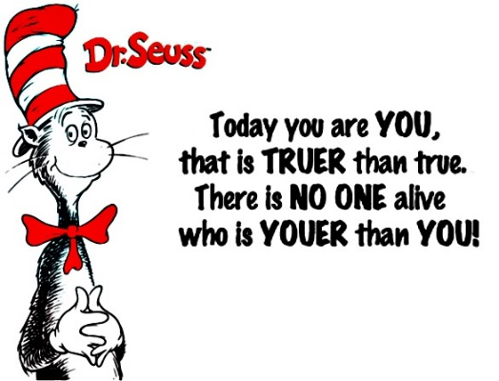
Introduction
Part of being human is experiencing moments of self-doubt and feelings of failure. Even the most confident and successful individuals experience this. However if you experience these negative thoughts frequently and they interfere with living a healthy and happy life, it may be time to take action. Building self-esteem is a life-long journey that can be challenging but also very rewarding. In this workbook, you will complete various activities focused on building self-esteem. These activities will help develop your self-esteem, equipping you for the obstacles and challenges that arise in life’s journey.

About Me
Let’s take a moment to identify your own positive traits and characteristics and celebrate your accomplishments.
- I was really happy when….

- Something that my friends like about me is….

- I’m proud of….

- My family was happy when I…..

- In school, I’m good at…..

- Something that makes me unique is….

Beauty – Inside and Out
Beauty comes in all different types. There are many ways to be beautiful, both on the inside and or on the outside. When something about you is appealing to others, whether it is your looks, your smarts, your personality, or your kindness, that is a beautiful thing. List some ways that you are beautiful either on the inside or out.
1.
2.
3.
4.
5.

Toot Your Horn
Now let’s explore what makes you good and likable. Complete at least 15 of the 18 statements below:
- I like myself because….
- I’m an expert at…..
- I feel good about….
- My friends would tell me I have a great…..
- My favorite place is….
- I have been told I have pretty…..
- I consider myself a good…..
- What I enjoy most is……
- The person I admire the most is….
- I have a natural talent for.....
- Goals for my future are….
- I know I will reach my goals because I am…..
- People compliment me about…..
- I feel good when I….
- I’ve been successful at…..
- I laugh when I think about….
- The traits I admire myself for are…..
- I feel peaceful when…..

Self-Esteem Journal
Finish the following statements:

- Something I did well today….
- Today I had fun when….
- I felt proud when….

- Today I accomplished….
- I had a positive experience with….
- Something I did for someone….

- I felt good about myself when…
- I was proud of someone else…..
- Today was interesting because….

Self-Confidence / Self-talk
Part 1 Think about a situation in which you felt confident and experienced a sense of self-worth and answer the following questions:
- What is the situation?

- What do you say to yourself about the situation (self-talk)? How do you feel physically?

- What sensations and feelings do you have in your body?

- What do you do as a result of this?

Part 2 Think of a current situation in which you experienced a lack of confidence that you would like to change if you could.
- What is the situation?

- What do you say to yourself about the situation (self-talk)?

- How do you feel physically? What sensations and feelings do you have in your body?
- What do you do as a result of this?

Part 3 Look at Part 2 and using the information that you have learned about yourself in Part 1, ask yourself – When I am in this situation:
- What positive statement could I say to myself to be reminded of my power?

- What could I do that would help me feel differently? (For example, create a visualization in which I remember how I felt in Part 1)

- What could I do differently, next time I am in this situation? What actions would empower me?

My Goals
Striving towards and achieving one’s goals is an important and valuable way to build self-esteem. You build the most solid foundation of self-esteem and self-confidence on the building blocks of positive experience and success. Think about and list the goals you would like to accomplish in the future.
Setting Goals:
Something I want to accomplish in the next week:

Something I want to accomplish in the next month:

Something I want to accomplish in the next year:
Something I want to accomplish in the next 5 years:

Obstacles and Strategies
What are obstacles to reaching my goals?

Things I will need to do to achieve my goals.

What can I begin doing tomorrow to work toward my goals?

Flipping Your Mistakes, Failures and Obstacles
Everyone fails sometimes and it is important to learn to accept failures and use them to learn and improve chances of future success. Failure happens to everyone but it does not mean that the one who failed IS and failure. List the mistakes, obstacles, and failures you would like to turn around in your life, then in the “How I will Flip it” column, write the step you will take to change things.
Mistakes, Failures, Obstacles | How I will Flip it

Remember: The purpose of “Flipping It” is to empower yourself and make you see that there is a way out, so rather than just accepting a bad situation as your “fate” empower yourself and FLIP IT!
