Nutrition Project Name:
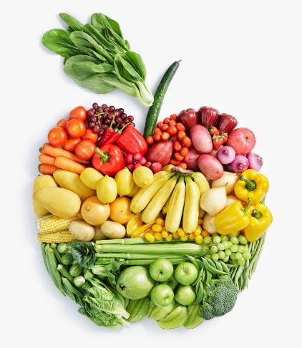
Resources:
www.myplate.gov
www.eatright.org
www.thespruceeats.com
www.farmflavor.com>Georgia
Work with 1 other person.
Part 1: Neatly written or typed
Name the Daily Recommended Amounts of nutrients for a 16 year old active teen. Nutrients: carbohydrates, proteins, fats, vitamins, minerals, and water
Design a balanced diet for a disease free 16 year old active teen for 1 day. Make sure to include healthy proportions of all the food groups or nutrients. You must include a specific menu with nutritional information for each item.
Part 2: Make a product
Using your written product from part 1, create a visual aid (poster, digital document, etc.) of your balanced daily food choices. Categorize pictures of your foods into the food groups. Include a diagram of 3 plates (breakfast, lunch and dinner) indicating the proper proportions of the food groups in one day of meals. You may also include snacks. Make sure you label your foods and groups and proportions.
Part 3: Analyze (neatly written or typed)
Analyze your daily eating habits. How do they compare or contrast to the Daily Recommended Amounts you researched above? What changes do you need to make to your eating habits.
Part 3 Analysis

Part 4: What’s in season? (neatly written or typed)
Identify 10 fruits and vegetables that are in season (fresh) in Georgia during the 4 seasons: Fall, Winter, Spring, and Summer.
Part 4: Seasonal Fruits and Veggies
Fall | Winter | Spring | Summer
1.
2.
3.
4.
5.
6.
7.
8.
9.
10

