Healthy Choices and Sex
Desirable Character Traits – define
- Goal-

- Determination-

- Wisdom-

- Responsibility-
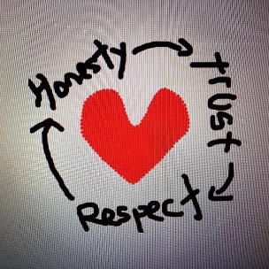

- Honesty-

- Self-Respect-

- Abstinence-

- Self-Discipline-

- Courage-

- Boundaries -

Risky Sexual Behavior
- What are examples of risky sexual behaviors?

- How can substance abuse effect an individual’s decision making with regards to risky sexual behavior?

- List some consequences, both physical and emotional, of premarital sex.
  - –
  - –
  - –
  - –
  - –
Sexually Transmitted Diseases
- List 5 forms of contraception.

- Which form of contraception is most effective against the spread of HIV?

- Which of these 3 types of STD’s can be cured and how?

  - Viral STD b. Bacterial STD c. Parasitic STD

- Chlamydia

- Genital Herpes
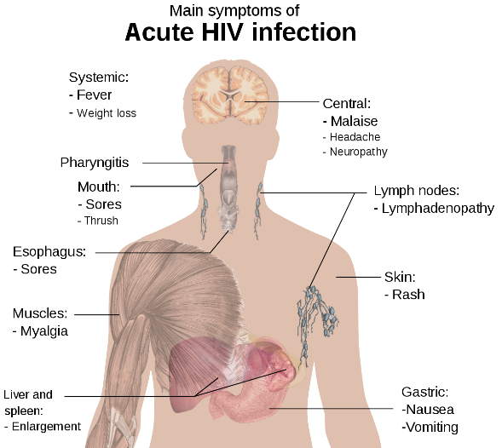

- HPV

- Gonorrhea

- HIV

- AIDS

- Pelvic Inflammatory Disease

- Can you outwardly tell if someone has an STD?

- What is the only 100% way to avoid contracting an STD?
Relationships
- What is the difference between love and infatuation?

- Describe an appropriate sequence of developing a healthy relationship from a first meeting to a sexual relationship.

- How can emotions, infatuation, and sex interfere with the healthy development of a relationship?

- The five C’s to developing healthy relationships:

  - C
  - C
  - C
  - C
  - C

Refusal Skills
- List 3 reasons for teens to remain abstinent.

- What barriers can interfere with your ability to maintain boundaries?

- Create a refusal strategy for resisting pressures to be sexually active. Hint: think about what the diagram above is saying

- Explain how you can refuse pressures to be sexually active and still maintain a healthy relationship.

Babies
- What is the average annual cost of raising a baby?

- How does teenage pregnancy usually effect the teenage relationship?

- How does teenage pregnancy effect the parent’s ability to pursue their goals?

Conclusion
- What is the only 100% way to ensure that you are free from the risks of STD’s, pregnancy, and negative emotional consequences associated with premarital sex?

