Bowling

History of Bowling
Bowling balls and pins were found in the tomb of an Egyptian king who died in 5,200 B.C. Bowling was part of a religious ceremony in 4th century Germany. Those who could knock down the pins were said to be of good character. Those who missed had to do penance.

The Lane & Equipment
The playing surface is a lane, ________ feet long from the foul line to the head pin 42 inches wide. On either side of the lane are gutters; if the ball goes off the edge of the lane, it will drop into the gutter and be carried past the pins. The ___________ is an area 15 feet long, ending at the foul line. The bowler, in making the approach, must not step over the line.
The pins are arranged in four rows, with one pin in the first row, two in the second, three in the third, and four in the fourth. They are numbered _________; the pins themselves don't carry specific numbers, but the spots on which they are placed do.

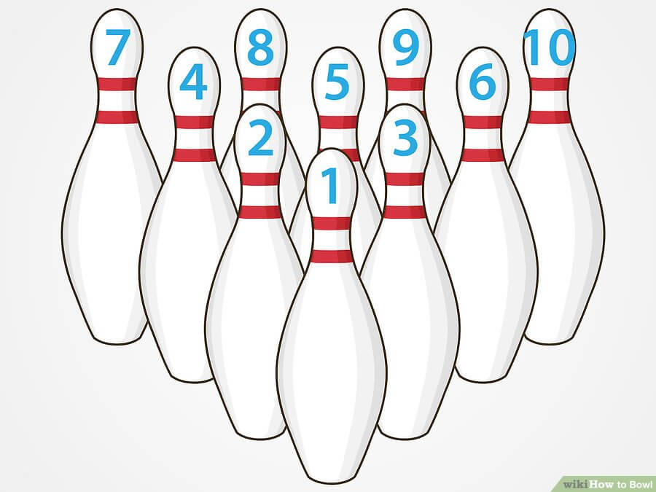

A ball may have two or three finger holes; most bowlers use the three-holed ball, inserting the two middle fingers and the thumb into the holes.
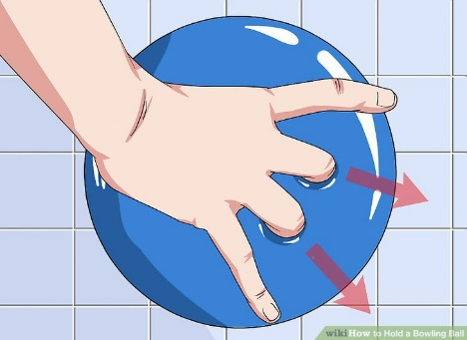
Game Play
A game is made up of 10 ____________. If the player knocks down all the pins with the first roll, it is a ___________; if not, a second roll at the pins still standing is attempted. If all the pins are knocked down with two balls, it is a _____________. In the case of a spare, a __________ mark is recorded in a small square in the upper right-hand corner of that frame on the score sheet, and no score is entered until the first ball of the next frame is rolled. Then credit is given for 10 plus the number of pins knocked down with that next ball.
If a bowler gets a strike, it is recorded with an _______ in the small square, the score being 10 plus the total number of pins knocked down in the next two rolls.
If any pins are left standing after the second roll, it is an "______________________"
Bowling's perfect score is a ___________game. This represents 12 strikes in a row. Why 12 strikes, instead of 10? Because, if a bowler gets a strike in the last frame, the score for that frame can't be recorded before rolling twice more. Similarly, if a bowler rolls a spare in the last frame, one more roll is required before the final score can be tallied.

Lane Etiquette
- Wait for the bowler to your __________________ to deliver his/her ball if you're both bowling at about the same time.
- Remain _________________ your fellow bowler while he/she is bowling.
- Confine your bowling to your own lane.
- Observe the foul line, even in casual play.
- Never bowl in street shoes.
- Avoid using someone else's ball without permission.
- Limit swearing and bad language as much as possible.
- Be ready when it's your turn.
