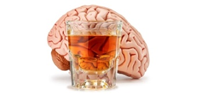
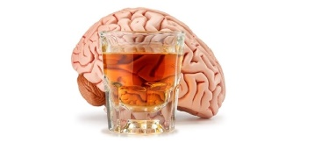
Round Robin Research: Alcohol and the Body
- Describe what happens to the brain when someone has a hangover. How do you cure a hangover?

- Find a local rehab facility for alcohol recovery. How much does it cost? What kind of programs does the facility offer? What is required of an individual?

- What is an intervention? How does an intervention take place? Who is involved in an intervention?

- Discuss why scientist believe some individuals become alcoholics while others do not.

- What is cirrhosis of the liver? What is the treatment for the disease? What is the prognosis for the patient?

- What is AA? Describe their 12 step program.

- What Georgia laws exist that are related to alcohol consumption and driving? What are the ramifications for each offense?

- How can families be effected by alcoholism? What resources are available to the families?

- Create a plan to guide an individual from alcoholism to sobriety. Make sure to address both the mental and physical aspects of recovery.

